Title: Evaluation of national level digital training program on mental health aspects of Gender Based Violence for One Stop Centre counsellors in - India

Abstract:
Introduction
Gender-based violence (GBV) remains a critical public health concern globally, with significant mental health implications for women facing violence. One Stop Centres (OSCs) in India are services funded by the government that offer integrated support for GBV survivors, including legal, medical, and counselling services. Given that GBV is strongly associated with poor mental health, the Stree Manoraksha digital training program was initiated with funding and support of the Ministry of Women and Child Development. The program aimed to enhance capacity of the OSC counsellors’ identifying and managing GBV-related mental health problems among women.
Methods
The training, conducted from April-October 2022 across 31 states and UTs, 623 OSCs, in 8 languages was in the form each 6 online sessions of 3.5 hours each online mode, a total of 21 hours. The teaching was done employing various interactive and reflective educational methods all conducted in an online mode. Pre and post-training assessments evaluated knowledge enhancement and skill development, focusing on identifying mental health problems, suicidal risk, psychological first aid, tele counselling, self-care for counsellors.
This study aimed to assess the impact of training on improving knowledge, attitudes and level of confidence that would influence service delivery of GBV services.
While 1404 counsellors participated in this nationwide program, both pre- and post-training evaluations were available for 362 participants.
Results

Out of 1109 counsellors trained, had only 1085 pre and 864 had post training assessments. Both pre and post training data was available for 362.The training led to significant improvements across key domains: overall knowledge increased from 7.21 to 7.95 (p < 0.001), and mental-health–specific knowledge improved from 2.52 to 3.04 (p = 0.001). Counsellors’ confidence in assessing violence, making safety plans, providing first-level interventions, and managing special populations also rose significantly (overall confidence 55.86 to 58.07, p < 0.001). Awareness of GBV, local resources, and related mental-health issues shifted markedly from low/average to high (p < 0.001). Personal beliefs and attitudes improved substantially (18.66 to 13.23, p < 0.001). No significant change was observed for suicide-related skills (p = 0.35) or multigenerational trauma understanding (p = 0.72). Overall, the digital training produced meaningful gains in knowledge, preparedness, and attitudes among OSC counsellors nationwide.
Conclusions
The findings highlight the effectiveness of digital training in low-resource settings in enhancing knowledge in the areas of mental health, awareness, confidence, personal beliefs offering a scalable model to integrate mental health into GBV interventions. The Stree Manoraksha program sets a precedent for building capacity in trauma-informed, culturally sensitive care across India’s OSCs. Scaling such initiatives and addressing systemic barriers can improve the quality of support for GBV survivors, ensuring holistic care that addresses both immediate and long-term needs.

INTRODUCTION

Gender-based violence (GBV) refers to violence "directed at an individual based on their gender", and the burden is disproportionately borne by women and girls (termed VAWG; Violence against Women and Girls)[1]. Globally, about 30% of women have experienced physical, emotional, or sexual violence from an intimate partner [2]. The rates are higher in low and middle-income countries. In India, according to the National Family Health Survey-5, about 29% of women aged 18-49 have ever experienced physical violence, about 6% of women aged 18-49 have ever experienced sexual violence in India in their lifetime, and about 14% of women aged 18-49 have experienced emotional violence in India. Moreover, 29.3% of all married women aged 18–49 years have experienced spousal violence at least once in their life[3]. Despite this high burden, most women in India who experience violence fail to seek help from formal agencies like the police or legal system. Studies suggest that only between 14 and 24% of women have sought any form of help, with less than 2% approaching organisations such as protection agencies or the police, often due to social stigma, fear of escalation of violence, lack of alternative financial and social support resources, and systemic barriers to access[4–7].
The mental health burden associated is profound. The Lancet Psychiatry Commission has highlighted that exposure to intimate partner violence (IPV) and GBV across the life span significantly increases the risk of mental health problems, including depression, anxiety, post-traumatic stress disorder (PTSD), suicidal ideation, and suicide attempts [6]. Knowledge of both the prevalence and skills in screening for mental health and substance abuse problems among survivors seeking help is therefore crucial to understanding their experiences and ensuring appropriate referrals [7].

Despite this recognized need, mental health screening is not routinely integrated into many programs addressing GBV, often due to lack of training, resources, and/or time[8]. Studies have further identified systemic challenges voiced by providers, including insufficient specialized training of professionals for these unique mental health needs, the low national prioritization of GBV/IPV as a public mental health problem, and an absence of coordination between agencies involved in supporting survivors [8–10]
Existing literature on GBV training programs for community health workers, social workers, and other first-line responders address components such as mental health inquiry, emotional consequences of violence, safety planning, or basic counselling skills; however, comprehensive mental health coverage remains limited (Table 1). Moreover, program outcomes are frequently measured using self-reported indicators or referral counts rather than broader changes in preparedness, attitudes, or knowledge.

[Table 1 in separate Excel file]

Evidence has shown that targeted mental health training for staff working in the field of GBV significantly improves the identification and referral of survivors to specialist services, strengthens collaboration between mental health and GBV professionals, and enhances outcomes for both survivors and patients with mental illness [11,12]. In low-resource settings such as India, such training can be delivered to community-based service providers and other frontline staff who work directly with clients and program participants.
In India, the Ministry of Women and Child Development, Government of India, in 2015, scaled up the number of One Stop Centres all over the country to improve services for women facing violence. These One-Stop Centres (OSCs) have been operational as a model of care to provide multidisciplinary resources to women facing violence, integrating immediate medical care, counselling, police and legal support[13–15]. As of September 2025, 876 OSCs are operational across India that have helped over 12 Lakh women across the country [16]. The OSCs are located in each district and staff include one central administrator, two case workers, one paralegal, one paramedical, one psycho-social counsellor, and an additional support staff[17].
Although OSC staff receive training in legal guidance, physical support, shelter, and basic counselling, the training provided to the staff does not focus on mental health issues. Given the high prevalence of mental health concerns among women experiencing violence, strengthening counsellors’ capacity to respond to mental health needs is critical in low-resource contexts.

Persistent gaps include limited provider preparedness, gender sensitivity challenges, lack of clear protocols for mental health care, insufficient privacy, and weak referral linkages with specialized services [18,19]. Against this backdrop of systemic and training gaps, the COVID-19 pandemic further intensified risks, with increasing rates of DV and GBV around the globe. Women were unable to reach domestic violence services due to lockdowns and travel restrictions, and mental health problems were also on the rise.
The Project Stree Manoraksha (Protection of Women's Mental Health) was initiated during the pandemic by the Ministry of Women and Child Development to support OSC counsellors by enhancing training on psychological and mental health and continued thereafter. This study evaluates the impact of the Stree Manoraksha training programme on OSC staff, specifically examining changes in their knowledge, beliefs and attitudes, perceived barriers, and preparedness to provide trauma-informed mental health and psychosocial support to women affected by violence.

METHODOLOGY

A) Training Program:
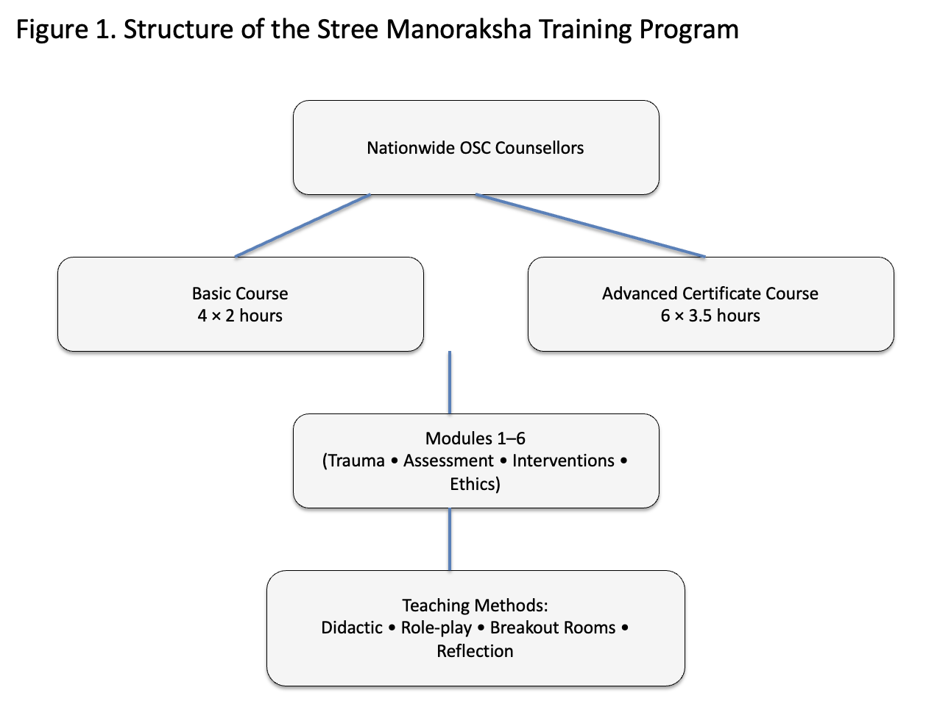
The structure of the Stree Manoraksha training program is presented in Figure 1.
The study intervention was an ongoing comprehensive training program delivered to participants in the "Stree Manoraksha" OSC training program conducted nationwide. Sessions were conducted over (i) four sessions of two hours each in a basic course directed at all participants and (ii) six sessions of 3.5 hours each for counsellors in an advanced certificate course for a total of 21 hours.
Teaching approaches included brief 15-20 minutes didactic trainings, hypothetical case vignettes pertinent to the subject, role play videos focusing on the interaction between client and counsellor, and personal testimonies. Breakout room discussions with a maximum of 10 participants were done on zoom so there would be better discussion in small rooms, considering the topic's sensitive nature. audio and video training videos, reflective exercises
Following the principles of participatory adult learning, the focus was built on learning through participants' experiences, with a systematic sharing of experiences by the trainees helping facilitate awareness of the socio-economic realities and allowing feedback.

Didactics were developed in English, Hindi, Kannada, Tamil, Telugu and Malayalam to cater to all regions. Session discussions were carried out in English, Hindi, Gujarati, Punjabi, Kannada, Tamil, Telugu and Malayalam.

Module | Learning objectives
Module 1 | 1.1 Violence against Women: Multigenerational Implications and Lifetime Trauma.
 | 1.2 Multigenerational Implications and Lifetime Trauma
Module 2 | 2.1 Psychological Impact of Trauma, Abuse and Violence
 | 2.2 Assessment of Mental Distress, Disorders and Suicide Risk Assessment
Module 3 | 3.1 Psychological Interventions for Women Facing Violence
 | 3.2 Tele Counselling
Module 4 | 4.1 Sexual Violence: Guiding Principles and Challenges in Managing Trauma.
Module 5 | 5.1 Violence in family context: Ways to intervene.
Module 6 | 3.1 Ethical and Professional principles in counselling
 | 3.2 Self-care for OSC staff

The Stree Manoraksha program also launched an online training platform (https://nimhansstreemanoraksha.in) on November 25, 2021, providing internally developed reading materials, audio-visual didactics, self-learning modules, and curated external resources to support continued learning.
B) PROGRAM EVALUATION
The impact of this training program was evaluated using a structured pre–post assessment design.
- SAMPLE

The survey instrument was administered at two points of time: one week before starting training (i.e. pre-training), and after completion of the training for all the counsellors who were enrolled for the advanced certificate course. Counsellors enrolled in the study received a link to an online questionnaire administered via the SurveyMonkey platform (given in Appendix).

- INSTRUMENT USED

A self-administered semi-structured questionnaire consisting of 55 items and 11 sections was prepared with relevant items adopted from the Physician Readiness to Manage Intimate Partner Violence Survey (PREMIS) scale[20], while adapting it to our population's unique legal and cultural milieu as per adaptations informed through discussions among the study team and consultation with subject-matter experts working in GBV and mental health. The questionnaire has the following sections:
- Demographic background (age, gender, qualifications),
- Details about prior training in gender-based violence (GBV) and their previous experience at the OSC,
- Barriers faced in assessing GBV,
- Current knowledge and awareness of clinical mental health issues among women facing violence,
- Personal attitudes towards GBV, and their
- Levels of confidence or preparedness in assessing and managing mental health issues.

Four domains were chiefly assessed:
- Barriers - 11 items assessing themes faced in the participants' previous work at the OSC, such as lack of time, lack of training, lack of privacy, lack of awareness of resources, and fears of offending or of facing legal issues. Survey participants were also invited to add barriers they had faced separately, if any. Themes were adapted from previous studies assessing barriers faced by mental health providers in an Indian context [21]

- Preparedness/Level of confidence - 15 items assessing the participants' level of confidence in a range of situations while addressing women facing GBV were assessed using a Likert scale from 'Not at all Confident' to 'Very Confident'. Themes included identification and assessment of violence in general populations (asking women directly about emotional, physical, or sexual violence; providing psychological first aid; making a safety plan), identification and assessment in special populations (handling cases of child sexual abuse; pregnant and elderly women facing GBV), and dealing with specific instances of mental health issues such as suicidal ideation and severe mental illnesses.

- Knowledge - Participants' self-assessment of their knowledge was assessed using three items – 1) How would you rate your knowledge of gender-based violence and intimate partner violence in general? 2) Do you have adequate knowledge in referring women facing GBV to local resources in the community? 3) Do you think that you need more training on gender-based and intimate partner violence?

Knowledge of GBV was assessed over a series of sections including a) Multiple Choice Based questions, b) True-or-False questions, and c) Questions based on potential case scenarios.

- Favourable and unfavourable Attitudes - Participants were asked to rate 7 statements on a 5-point Likert scale ranging from "Strongly Agree" to "Strongly Disagree" for statements that showed a favourable attitude towards GBV such as "It is important to screen for violence every time the woman visits the OSC", and negatively scored for unfavourable attitudes such as "Intimate partner violence cannot be prevented".

Test–retest reliability and content validity were assessed by sending the questionnaire to identified experts. Cronbach's alpha was calculated for each construct and inter-test reliability was found to be acceptable for all domains except Attitudes (Barriers = 0.926, Preparedness = 0.613, Knowledge = 0.665, Attitudes = 0.447).

- ETHICAL CONSIDERATIONS

The project was reviewed and approved by the NIMHANS Institutional Ethics Committee.

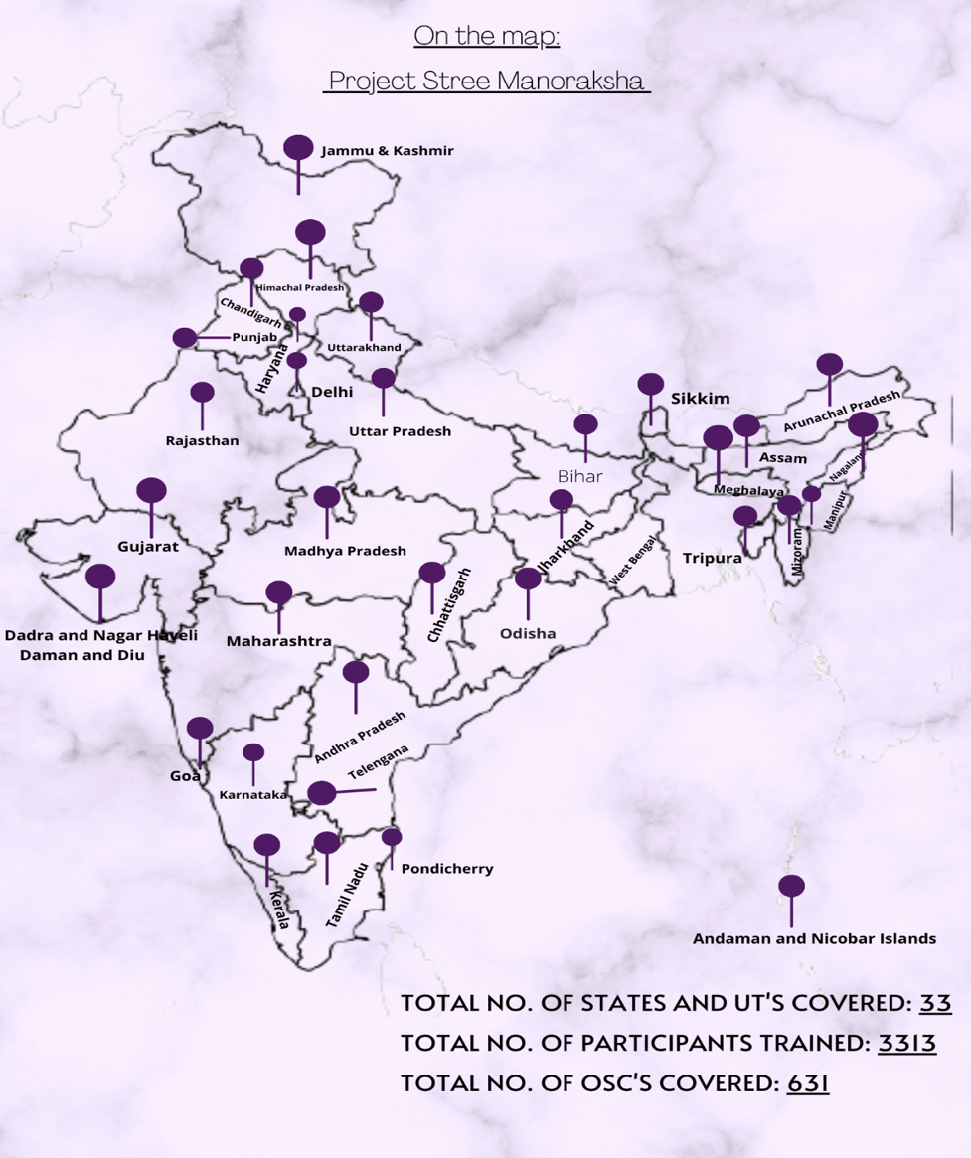
Figure 2 – Coverage of OSCs
ANALYSIS

Statistical analysis was performed with SPSS version 27. A descriptive analysis was done to summarise the socio-demographic details of participants. For scales in each section, items were reversed scored where necessary. Total and subscale scores were calculated and frequencies run to produce means, standard deviations and range of scores. Differences between pre- and post- intervention were analysed using inferential statistics (paired t-tests/ Wilcoxon signed rank test).

The time spent in filling the questionnaire was around 1 hour 12 minutes. The completion rate in filling the pre assessment was 66% and post assessment was 63%.

Results
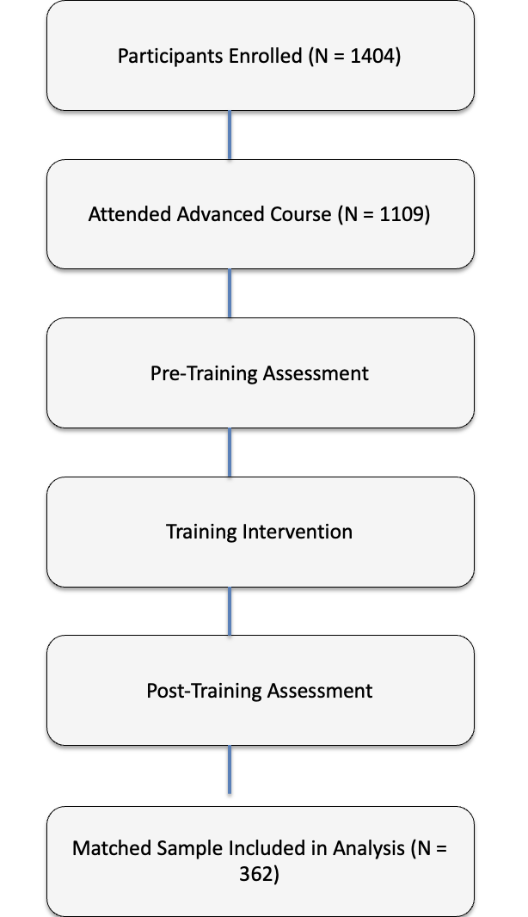
Figure 3
The assessment forms were sent online using survey monkey platform to 1109 participants; 1085 completed the pre-assessment, and 684 completed the post assessment; 362 responses were matched who had completed both the pre and post-test and was included in the analysis. The mean age of the participants (N=362) was 34.27 (±8.18) years; 97.5% were female counsellors, while 2.5% were males. 84 % (n=304) hold a master's degree.
183 (50.6%) had attended lectures on GBV, 134 (37%) had no formal training, 89(24.6%) Attended skill-based training workshops on GBV and 59(16.3%) had done a counselling/certificate course on Gender-Based Violence (GBV). 218 (60%) had less than three years' experience, and 116 (32%) had 3- 6 years of experience and 28 (7.7%) had more than six years of experience. 30 % reported seeing 10 or more women per week in the OSC setting.
Before presenting the matched pre-post findings, we first evaluated potential attrition bias by comparing participants who completed both surveys (‘matched) with those who did not complete the post-survey.
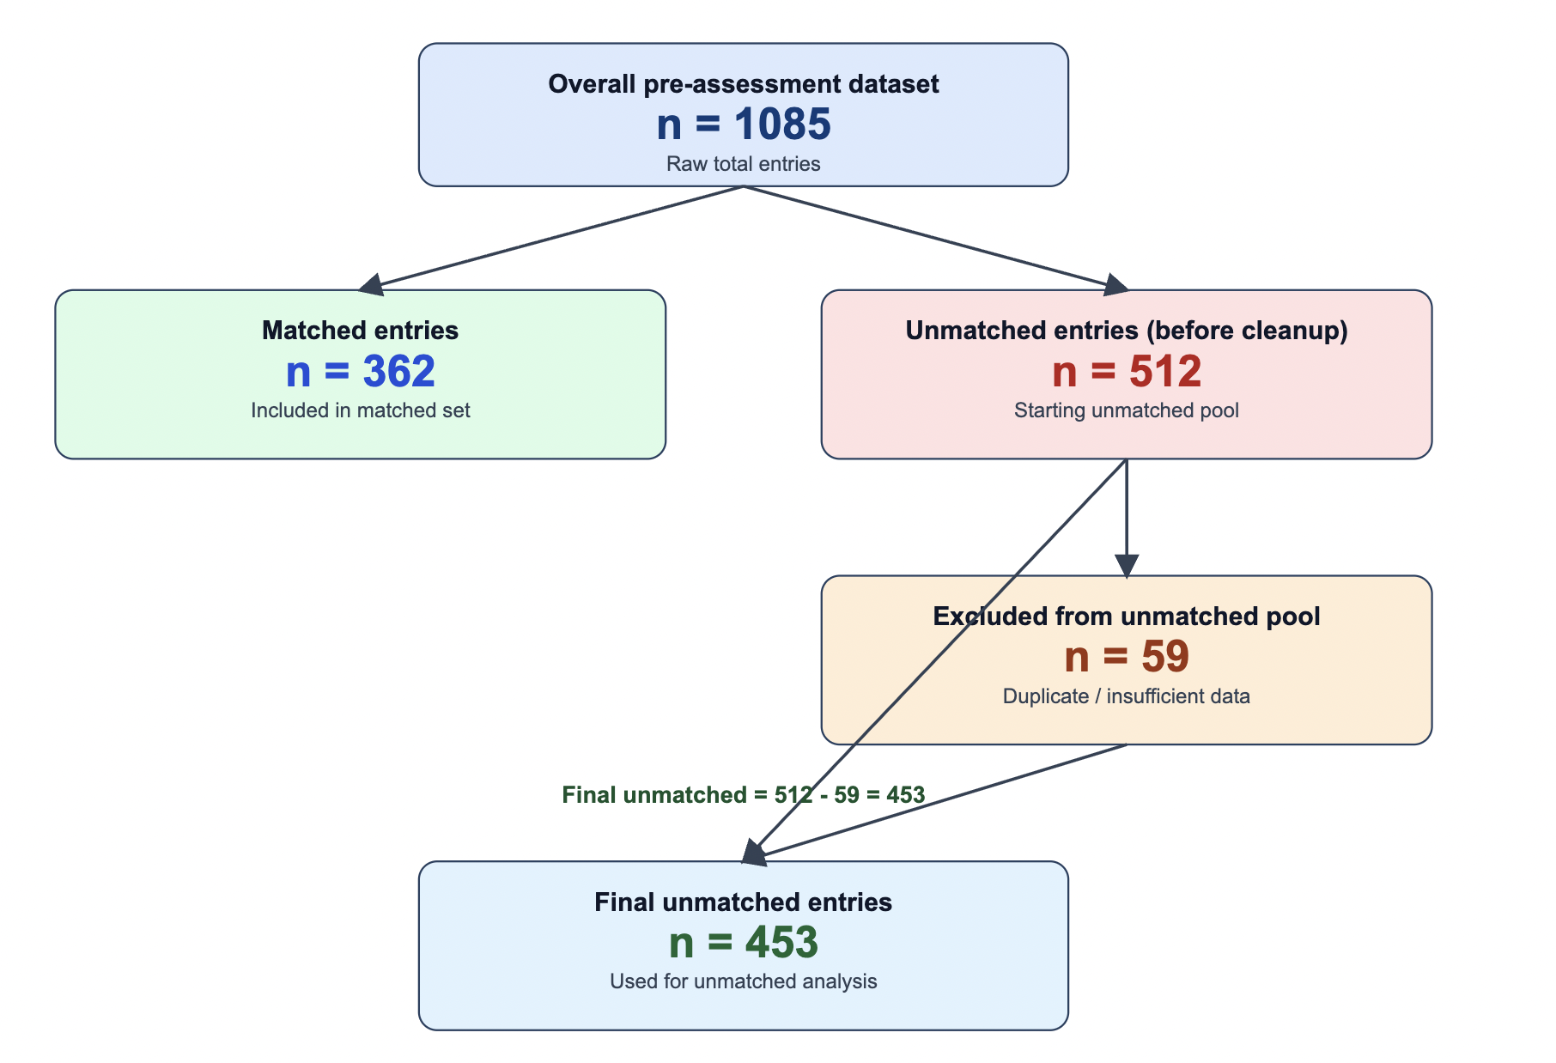
In those who completed both surveys (n=362) versus all unmatched pre-only records (n=512), item missingness was substantial in the unmatched group: 37.3% had at least one contact field missing, and 46.9% had at least one contact or demographic field missing. Because this level of missingness could bias inference, the primary comparative analysis used a cleaned unmatched cohort (n=453) after excluding records with contact identifiers missing.
In the primary analysis (362 matched vs 453 unmatched), matched participants were slightly younger than unmatched participants (mean age 34.27 ± 8.18 vs 35.41 ± 7.61; Welch t-test, p=0.0422). GBV caseload distribution also differed (χ² test, p=0.0494, Cramér’s V=0.104, small effect): matched participants were more concentrated in the <10 cases/week category, whereas unmatched participants were more concentrated in the 11–20 cases/week category. For prior GBV training, the only item-level difference was skill-based workshop exposure: 35.8% in unmatched vs 24.6% in matched (p<0.001, small effect). However, when training items were collapsed into “any formal training” versus “none,” no overall difference was detected (p=0.67).
Matched participants reported a higher mean barrier count than unmatched participants (2.10 ± 1.56 vs 1.78 ± 1.41; t-test, p=0.0026). Barrier items significantly more endorsed in matched participants were: “not adequately trained to assess IPV” (29.0% vs 15.2%, p<0.001), “not adequately trained to assess sexual violence” (27.3% vs 17.2%, p<0.001), “not adequately trained to assess domestic violence” (24.3% vs 17.0%, p=0.0099), and “belief that the situation is unlikely to change” (19.3% vs 13.0%, p=0.0142). The only barrier significantly more endorsed in unmatched participants was “feeling helpless when assisting women facing violence” (13.9% vs 8.8%, p=0.0251).
State distribution differed significantly between groups (χ²=145.36, df=31, asymptotic p=9.9×10^-17; simulated p=5×10^-5 due sparse cells), with Cramér’s V=0.42 (moderate-to-large association). North-eastern states showed high completion rates: Nagaland 91.3% (21/23), Manipur 80.0% (20/25), Mizoram 80.0% (12/15), and Meghalaya 72.4% (21/29). Telangana contributed the largest absolute number of completers (n=49), followed by Punjab (n=26) and Arunachal Pradesh (n=25). In contrast, Gujarat had low completion (8.3%, 5/60), while Andhra Pradesh (18.2%, 2/11), Jammu and Kashmir (20.0%, 2/10), and Uttarakhand (23.5%, 8/34) were all below 25%. Seven states/territories had fewer than 10 total respondents; these estimates should therefore be interpreted cautiously.

Barriers faced by OSC counsellors when assessing women with GBV (Pre-training)
Table 2 - Depicts the various barriers the OSC counsellors have faced while assessing women with GBV
Statements on barriers faced by the OSC counsellors | N (%) Pre assessment | N(%) Post assessment
Concerns about legal issues | 116(32%) | 100 (27.6%)
Not adequately trained to assess women who have faced Intimate Partner Violence | 105(29%) | 74 (20.4%)
Not adequately trained to assess women who have faced sexual Violence | 99(27.3%) | 74 (20.4%)
Not adequately trained to assess women who have faced Domestic Violence | 88(24.3%) | 56 (15.5%)
They are not likely to change their situation | 70(19.3%) | 58 (16%)
Afraid that you will offend or upset the women if you ask too much about violence at home | 59(16.3%) | 61 (17%)
Difficult to interview the woman alone because of a lack of privacy | 44(12.2%) | 39 (10.8%)
Not having enough time to assess women | 44(12.2%) | 67 (18.5%)
Not aware of resources/places to refer women facing violence | 43(12%) | 26 (7.2%)
Feel helpless when assisting women facing violence | 32(8.8%) | 27 (7.5%)
Don't know how to handle sessions if the perpetrator is also present | 25(6.9%) | 28 (7.7%)

Perceived confidence in assessing and addressing GBV
There were 15 questions on assessing confidence levels in the pre-and post-assessment, which were evaluated using a Likert scale ranging from very low to very high.

Table 3 - shows the total confidence levels and specific analysis in assessing various kinds of violence, providing first level interventions, and handling special population
 | Pre-assessment Mean (SD) | Post assessment Mean (SD) | p-value
Total confidence levels (N=317) | 55.86 (9.17) | 58.07(9.36) | <0.001
In assessing Emotional., physical and sexual violence (N=321) | 11.82 (1.99) | 12.12(2.13) | 0.013
In making a safety plan and providing first-level interventions(N=319) | 15.27 (2.52) | 15.91(2.51) | <0.001
In handling special population (pregnant women, elderly women, women disclosing child sexual abuse, women disclosing suicidal thoughts, women with anxiety/depression/or severe mental illnesses) (N=321) | 10.95 (2.19) | 11.38(2.16) | 0.001
P value using paired t test; p value <0.05 considered as the statistically significant.

Table 4 - Shows awareness of GBV, which are self-rated questions using the Likert scale of very low to very high
 | Pre (N=346) |  |  | Post (N=327)
Self-rated questions | Low N(%) | Average  N(%) | High  N(%) | Low N(%) | Average  N(%) | High  N(%) | P value
How much do you feel you know about gender-based violence and intimate partner violence? | 31 (8.95%) | 180 (52%) | 135  (39%) | 9 (2.75%) | 123  (37.6%) | 195 (59.63%) | <0.001
How would you rate your awareness about local resources in the community for women facing GBV? | 44  (12.71%) | 173 (50%) | 129 (37.28%) | 17 (5.19%) | 121 (37%) | 189 (57.8%) | <0.001
How would you rate your awareness of mental health issues related to gender-based violence? | 35 (10.11%) | 164  (47.4%) | 147 (42.48%) | 14 (4.28%) | 121  (37%) | 192 (58.71%) | <0.001
P value using Mc Neymar test; p value <0.05 considered as the statistically significant.

The significant McNemar test statistics (p-value < 0.05) suggest significant changes in participants' perceptions or awareness after the intervention for all three questions. In other words, the intervention had a positive impact on participants' knowledge and awareness regarding GBV, local resources, and mental health issues related to GBV.

Changes in knowledge related to IPV
There were knowledge-based multiple choice and true or false questions, in total 11 questions. The pre-mean score was 7.21±1.70, and post mean score was 7.95±1.67, N=260 [paired t-test: p=<0.001]. There was a significant change in the participants' knowledge. The questions addressed perceptions and legal aspects of GBV. They inquire about knowledge of GBV, awareness of local resources for victims, and understanding of mental health issues related to GBV. They also cover misconceptions about intimate partner violence, legal actions for victims, and reporting obligations for child sexual abuse in India.

Changes in knowledge-based questions on mental health
There were five multiple choice questions focussing on mental health in the assessment. The questions focussed on Recognising mental health issues: flashbacks, anxiety disorders, medically unexplained symptoms, depression interventions, and Understanding PTSD symptoms. There was a statistical change in the pre (2.52±1.15) and post-mean score (3.04±1.27), N=255 [paired t test: p=0.001].

Changes in the personal beliefs of counsellors
Faulty personal beliefs and favourable attitudes were measured using a Likert scale. It was noted that there was statistically significant change in the score of the personal belief N=160 pre mean score 18.66 ±3.39 to post mean score 13.23 ±3.07 [paired t test: p value (<0.001)].

Suicide and IPV
The questionnaire consisted of suicide related questions in a case scenario the mean score increased from 4.17±0.88 to 4.25±0.89, N=122, but it was not statistically significant
[ paired t test; p value= 0.35]
Multigenerational trauma
The questionnaire had case scenario explaining multigeneration trauma and related questions on identification, risk, and protective factors. The pre-4.08(±0.82) and post mean 4.13(±0.86), N=69 scores increased minutely and it was not statistically significant [paired t test= -0.354), p value= 0.725)].

Discussion
The 'Stree Manoraksha' was a comprehensive training program for integrating mental health
responses of counsellors responding to survivors of GBV in the One Stop Centres. This study
aimed to evaluate the barriers faced by these counsellors, and reports the changes in
counsellors' confidence and awareness of gender-based violence and its consequences. The
findings of this study report a significant improvement in knowledge related to GBV,
including the mental health aspects and resources for addressing the same.

The pandemic necessitated a shift to virtual platforms for 'Stree Manoraksha', with a curriculum allowing participants to engage with the material at their own pace, which is particularly beneficial for adult learners who may have other commitments. The online platform also allowed incorporation of various learning modalities, such as audio-visual slides and live webinars. An additional benefit was in our setting of a LAMIC was allowing scaling of a nationwide training program without additional costs and limitations of geographic barriers, reaching participants in remote and rural areas. The aim of this module was to help build local capacity, equipping counsellors with the necessary skills and knowledge to address IPV and associated mental health issues. Few studies have showed that online training was effective, role play improved attitudes, but group discussions had minimal impact and case studies led to modest gains. No studies reported on booster sessions (26, 27).

Training all OSC staff to recognise and respond to mental health issues associated with IPV ensures a holistic approach to client care. Early identification and intervention can significantly improve mental health outcomes for survivors, providing timely support and reducing long-term psychological impacts. Integrating mental health responses into the initial training ensures that all staff members have a baseline understanding of how to handle IPV cases sensitively and effectively. This standardisation promotes a consistent and reliable level of care across different centres, improving overall service quality. An additional benefit came in the form of didactic discussions which allowed an incorporation of local knowledge and practices into training.
The training program resulted in substantial gains in counsellors' knowledge and awareness of GBV, IPV, and associated mental health issues. This is evidenced by the significant increase in scores from pre- to post-training assessments. Counsellors demonstrated improved understanding of GBV, awareness of local resources, and mental health issues related to GBV.
The level of a counsellor's IPV knowledge is crucial for fulfilling their responsibilities. Literature agrees that education enhances practitioners' knowledge, positively impacting their ability to counsel IPV clients. This study found that IPV education significantly improves counsellors' knowledge and understanding, enabling them to more effectively support IPV clients. Opinions, knowledge, and perceived preparedness of students in the experimental group improved significantly compared to the control group (27). Another study showed significant improvements in mental health professionals' attitudes, knowledge, and preparedness to address IPV after a comprehensive intervention​ (28). A pre-post intervention study involving 201 healthcare providers in Maharashtra, India, assessed the impact of training on addressing violence against women. Post-training, significant improvements were observed in knowledge (median scores: 8.89 to 10.00), attitudes towards violence (9.05 to 10.00), and preparedness at both individual (6.74 to 10.00) and system levels (6.11 to 8.14). However, the improvement in attitudes and preparedness was not sustained at the 6-month follow-up. The study demonstrates the feasibility and positive impact of such training in low-resource settings, suggesting the need for continuous interventions to maintain these improvements over time (33).
There was a notable positive shift in counsellors' attitudes and beliefs towards GBV after the training. The program aimed to challenge existing myths and misinformation about GBV, encouraging more favourable attitudes towards survivors and the importance of screening for violence. The post-training assessments showed significant improvements in attitudes, as counsellors were more likely to agree with the necessity of screening for GBV during each visit and less likely to hold unfavourable beliefs that IPV cannot be prevented. The midwives' knowledge and attitudes toward domestic violence was improved by group and compact disc training methods (29).
The training significantly boosted counsellors' confidence in managing GBV cases. Confidence levels in identifying and assessing various forms of violence, providing psychological first aid, and making safety plans increased markedly. Moskovic (2008) found that outreach training for medical students more confident in dealing with adolescent IPV. Of 12 studies comparing IPV training to no intervention in different cadres of professionals, seven found that training improved healthcare professionals' readiness to respond to IPV. Six studies showed significant improvement within 12 months (SMD 2.44; P < 0.001), indicating a strong positive effect. (30). Haist (2007) and Short (2006b) investigated safety planning. Haist found improved safety planning post-training with simulated patients (P = 0.04) among residents, while Short found little impact among primary care physicians (31, 32).
The training program also addressed several barriers that counsellors face in providing effective support to GBV survivors. The most reported barriers pre-training included concerns about legal issues, lack of training, and fears of offending or upsetting the victims. However, some barriers such as lack of privacy and time constraints remained significant challenges, suggesting a need for systemic changes in the OSCs to support the counsellors better. Furthermore, the study by Bhate-Deosthali et al. (2018) suggests that addressing these systemic barriers is crucial for the effective functioning of OSCs​​.
Limitations – The study's methodology faced several limitations. Pre- and post-assessments conducted immediately after training lacked a contemporaneous control group, potentially introducing bias if conditions differed across time points. Clinical changes in practice were not assessed, highlighting the need for follow-up evaluations and refresher courses, as the impact of educational programs often diminishes over time. Additionally, the use of Survey Monkey forms presented challenges with validity, particularly in diverse cultural contexts, and language-related issues in translations may have influenced participants’ responses. Institutionalized mechanisms for ongoing training and reinforcement are essential to sustain long-term benefits. A key strength of the study is its large sample size, which enhances the reliability of findings. Additionally, the inclusion of diverse populations and multilingual resources ensured cultural and regional relevance, making the program’s outcomes broadly applicable across India’s varied contexts.

Conclusions
The positive outcomes of the training program suggest that similar initiatives could be beneficial if implemented more broadly across different settings. Policymakers should consider supporting and scaling up such training programs to improve the quality of care provided to GBV survivors. Furthermore, addressing systemic barriers through policy changes, such as ensuring adequate privacy and reducing workload pressures on counsellors, could further enhance service delivery.
In conclusion, the study demonstrates that comprehensive training programs can significantly improve the knowledge, attitudes, and confidence of counsellors in dealing with GBV, ultimately leading to better support for survivors. Continued efforts in training and systemic improvements are essential to sustain these gains and ensure that survivors receive the best possible care.
Acknowledgements
The training was part of the Project funded by Ministry of Women and Child Development.
References

1. Gender-based Violence - Inter-Agency Field Manual on Reproductive Health in Humanitarian Settings - NCBI Bookshelf. Accessed March 27, 2024. https://www.ncbi.nlm.nih.gov/books/NBK305160/
2. Organization WH. Violence against Women Prevalence Estimates, 2018: Global, Regional and National Prevalence Estimates for Intimate Partner Violence against Women and Global and Regional Prevalence Estimates for Non-Partner Sexual Violence against Women. World Health Organization; 2021.
3. National Family Health Survey. Accessed March 27, 2024. https://rchiips.org/nfhs/
4. Ghoshal R, Patil P, Sinha I, et al. Factors associated with help-seeking by women facing intimate partner violence in India: findings from National Family Health Survey-5 (2019–2021). BMC Global and Public Health. 2024;2(1):25. doi:10.1186/s44263-024-00056-3
5. Leonardsson M, San Sebastian M. Prevalence and predictors of help-seeking for women exposed to spousal violence in India – a cross-sectional study. BMC Womens Health. 2017;17:99. doi:10.1186/s12905-017-0453-4
6. The Lancet Psychiatry Commission on intimate partner violence and mental health: advancing mental health services, research, and policy - The Lancet Psychiatry. Accessed March 27, 2024. https://www.thelancet.com/journals/lanpsy/article/PIIS2215-0366(22)00008-6/fulltext
7. Stover CS, Lent K. Training and certification for domestic violence service providers: The need for a national standard curriculum and training approach. Psychology of Violence. 2014;4(2):117-127. doi:10.1037/a0036022
8. Simmons CA, Lindsey L, Delaney MJ, Whalley A, Beck JG. Real-World Barriers to Assessing and Treating Mental Health Problems With IPV Survivors: A Qualitative Study. J Interpers Violence. 2015;30(12):2067-2086. doi:10.1177/0886260514552275
9. Grigaitė U, Klidziūtė G, Aluh DO, et al. Responding to the needs of survivors of intimate partner violence in Lithuania: perceptions of mental health and social care professionals. Women Health. 2024;64(7):559-572. doi:10.1080/03630242.2024.2382419
10. Simmons CA, Delaney MJ, Lindsey L, Whalley A, Murry-Drobot O, Gayle Beck J. Should Programs Designed to Help IPV Survivors Screen for Mental Health-Related Problems: Voices From the Field. Violence Against Women. 2017;23(5):603-622. doi:10.1177/1077801216646225
11. Gregory A, Ramsay J, Agnew-Davies R, et al. Primary care Identification and Referral to Improve Safety of women experiencing domestic violence (IRIS): protocol for a pragmatic cluster randomised controlled trial. BMC Public Health. 2010;10(1):54. doi:10.1186/1471-2458-10-54
12. Trevillion K, Hughes B, Feder G, Borschmann R, Oram S, Howard LM. Disclosure of domestic violence in mental health settings: A qualitative meta-synthesis. Int Rev Psychiatry. 2014;26(4):430-444. doi:10.3109/09540261.2014.924095
13. Barriers and Facilitators to Integrating Health Service Responses to Intimate Partner Violence in Low‐ and Middle‐Income Countries: A Comparative Health Systems and Service Analysis - Colombini - 2017 - Studies in Family Planning - Wiley Online Library. Accessed March 27, 2024. https://onlinelibrary.wiley.com/doi/full/10.1111/sifp.12021
14. Bhate-Deosthali P, Pal P, Hogan M. Toolkit for Designing One-Stop Crisis Centres for Survivors of Gender-Based Violence:
15. Verma P, Puri P, Sharma D, Singh S. Role of ‘One Stop Crisis Centre’ in Identifying and Assisting Victims of Violence in an Indian Health Care Setup. Cent Asian J Glob Health. 9(1):e297. doi:10.5195/cajgh.2020.297
16. Sabha L. GOVERNMENT OF INDIA MINISTRY OF WOMEN AND CHILD DEVELOPMENT.
17. 1580720897_OSC_G.pdf. Accessed July 26, 2024. https://sakhi.gov.in/assets/site/main/resource_directory/1580720897_OSC_G.pdf
18. García-Moreno C, Hegarty K, d’Oliveira AFL, Koziol-McLain J, Colombini M, Feder G. The health-systems response to violence against women. The Lancet. 2015;385(9977):1567-1579. doi:10.1016/S0140-6736(14)61837-7
19. Chattopadhyay S. The Responses of Health Systems to Marital Sexual Violence – A Perspective from Southern India. Journal of Aggression, Maltreatment & Trauma. 2019;28(1):47-67. doi:10.1080/10926771.2018.1494235
20. Short LM, Alpert E, Harris JM, Surprenant ZJ. PREMIS: A Comprehensive and Reliable Tool for Measuring Physician Readiness to Manage IPV. Am J Prev Med. 2006;30(2):173-180. doi:10.1016/j.amepre.2005.10.009
21. Mathur P, Sharma LP, H Nanjundaswamy M, S Chandra P. Training needs of psychiatry residents in handling Intimate Partner Violence (IPV) in clinical situations—A survey. Asian J Psychiatr. 2020;53:102379. doi:10.1016/j.ajp.2020.102379
27. Ayaba-Apawu, Alvis Talata, "Intimate Partner Violence (ipv) Counselor Education: Exploring Opinions, Knowledge And Perceived Preparedness To Counsel Ipv Clients" (2016). Wayne State University Dissertations. 1427.

28. Vranda MN, Kumar CN, Janardhana N. Development and training of mental health professionals in providing psychological intervention and support for women survivors of intimate partner violence- A pre-post evaluation study. Ind Psychiatry J 2022;31:325-30

29. Vakily, Masoomeh; Noroozi, Mahnaz^{1,}; Yamani, Nikoo². Comparing the effect of group-based and compact disk-based training on midwives' knowledge and attitude toward domestic violence in women of reproductive age. Journal of Education and Health Promotion 6(1):p 70, | DOI: 10.4103/jehp.jehp_44_16

30. Kalra N, Hooker L, Reisenhofer S, Di Tanna GL, García-Moreno C. Training healthcare providers to respond to intimate partner violence against women. Cochrane Database of Systematic Reviews 2021, Issue 5. Art. No.: CD012423. DOI: 10.1002/14651858.CD012423.pub2

31. Haist, S. A., Wilson, J. F., Lineberry, M. J., & Griffith, C. H. (2007). A Randomized Controlled Trial Using Insinuated Standardized Patients to Assess Residents' Domestic Violence Skills Following a Two-Hour Workshop. Teaching and Learning in Medicine, 19(4), 336–342. https://doi.org/10.1080/10401330701542495

32. Short LM, Surprenant ZJ, Harris JM Jr. A community-based trial of an online intimate partner violence CME program. American Journal of Preventive Medicine 2006;30(2):181-5. [DOI: 10.1016/j.amepre.2005.10.012] [PMC1413953] [PMID: 16459218]

33. Arora S, Rege S, Bhate-Deosthali P, Thwin SS, Amin A, García-Moreno C, Meyer SR. Knowledge, attitudes and practices of health care providers trained in responding to violence against women: a pre- and post-intervention study. BMC Public Health. 2021 Nov 1;21(1):1973. doi: 10.1186/s12889-021-12042-7. PMID: 34724912; PMCID: PMC8561996.

